Meeting with Dr. Chung Sik Yong

Yesterday, January 4th, at 9:15 PM Paraguay time, we had a Zoom meeting with Dr. Yong Sik Yong, Chairman of Tong-Il Moo-do International. Dr. Yong's words of inspiration were directed to the Tong-Il Moo-do group of the Hisao Lee Martial Arts School, founded by Grand Master Fabio Perez. Also participating were Dr. Venus Agustin, Vice President of Tong-Il Moo-do International; Rev. Jacobo Lim, President of Central America for the FFUPM; Rev. Toribio de Lora, National President of the FFUPM of Panama; and Grand Master Diosdada Ladica do Santos of Latin America.

The Zoom meeting was hosted by President Toribio , and we had a meeting that lasted almost two hours. Grandmaster Fabio Perez expressed his gratitude for the meeting and explained the importance of holding the World Peace Cup Tournament in Panama in November due to the large number of government officials who could participate, including inviting the President of the Nation.

The most important thing was inviting people to the 40-day TIMD seminar in Korea. The participants are very motivated. Of the 17 participants, the Hisao Lee School requested support from Pandeporte, Panama's public sports organization, for 6 plane tickets, and the rest are purchasing their own. We expect to know precisely who will be going to Korea in the coming days.

The Hisao Lee School is recognized for its 53 years of work for the benefit of Panama. Beyond its large membership, it is the largest volunteer force in the country. Especially when the pandemic hit, 400 volunteers worked for over a year packing food for distribution throughout the country.

With a Christian background, Hisao Lee always focused on spiritual education and values. Only Tong-Il Moo-do was accepted by them to teach the Divine Principles.

HJ Global News Español (13.12.2025)
https://youtu.be/ZAZQjpY5fcQ?si=4yIvtMRYo0d2n1uc At minute 11.04, the Exhibition Tournament held recently in Panama is shown.

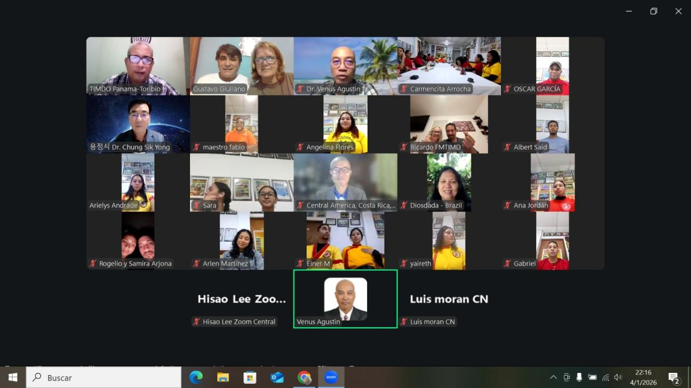
Photo of the meeting between the Tong-Il Moo-do group from Panama and Dr. Chung Sik Yong

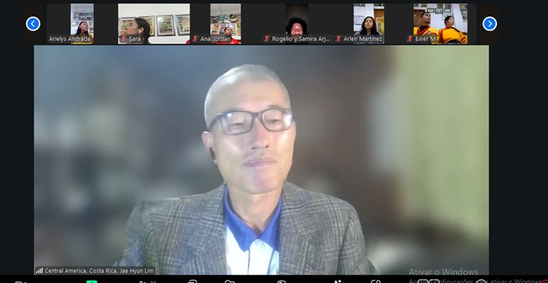
The President of Central America, Rev. Jacobo Lim

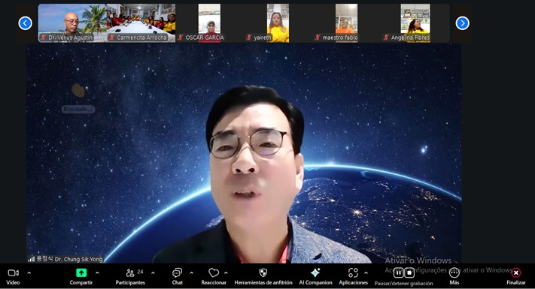
Dr. Chung Sik Yong

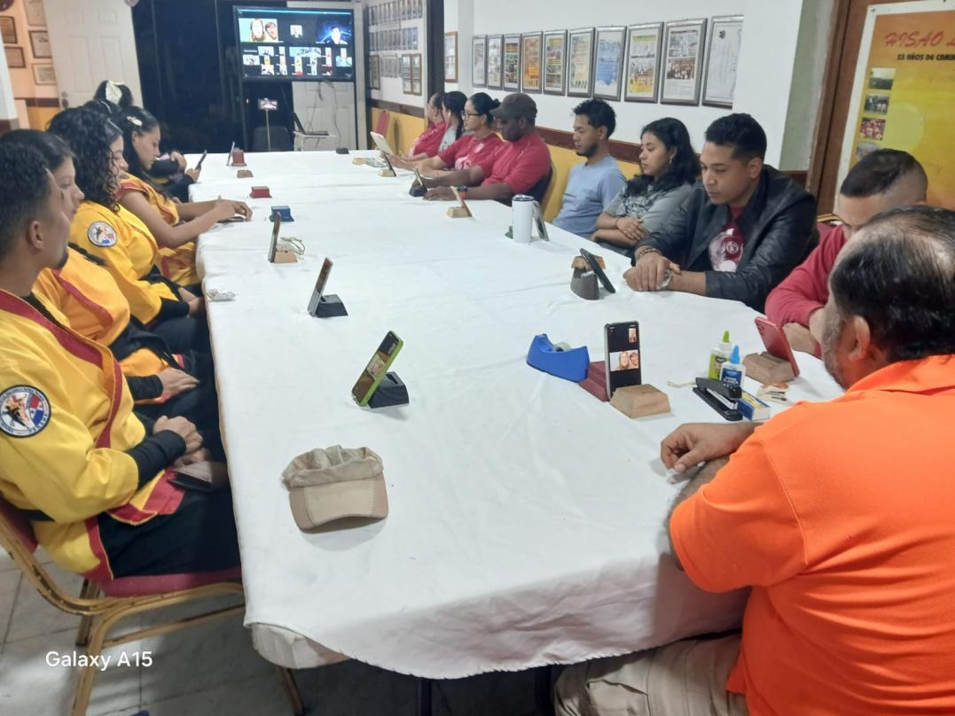
Tong-Il Moo-do group from the Hisao Lee Martial Arts School with Grand Master Fabio Perez.

Report by Gustavo Giuliano

